
Project Design Phase

Solution Architecture – ShopEZ

Date : 18 February 2026

Team ID : LTVIP2026TMIDS84411

Project Name : ShopEZ: One-Stop Shop for Online Purchases

Maximum Marks: 4 Marks

Solution Architecture Description
The ShopEZ solution architecture bridges the gap between the business challenges of fragmented online shopping and the technical implementation of a unified, scalable e- commerce platform.
It is designed using the MERN stack (MongoDB, Express.js, React.js, Node.js), ensuring a modern, full-stack JavaScript environment that supports rapid development and scalability.

Goals of the Solution Architecture
- Identify the best tech stack to solve the problem of disconnected buyer-seller experiences
- Define the structure and behavior of the ShopEZ platform, including frontend, backend, and database layers
- Outline key features such as personalized product feeds, seller dashboards, secure checkout, and multilingual support
- Break down development phases into modular sprints (e.g., user auth, product catalog, cart C checkout, analytics)
- Provide clear specifications for APIs, data models, and user flows to guide development and stakeholder alignment


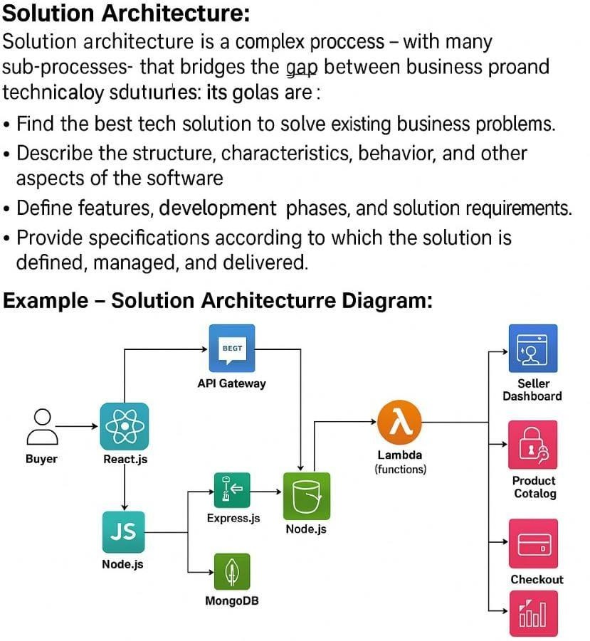

Reference: https://github.com/MittanaBhagyalaxmi33/SHOPEZ-MERNSTACK-APPLICATION

